Arsenic and Old Lace, a comedy by Joseph Kesselring
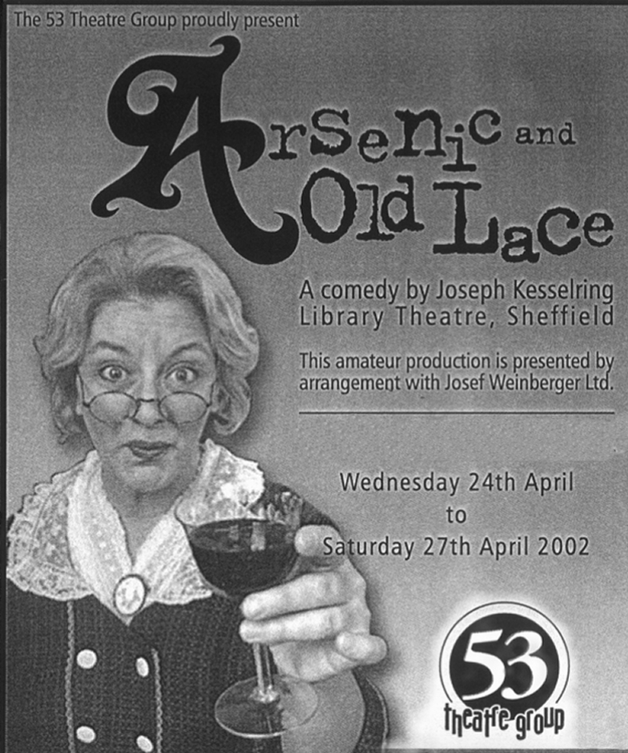
Directed by Sylvia Creaser
April 2002
Cast
Abby Brewster | Sheila Gascoyne
Rev Dr Harper | Brian Ward
Teddy Brewster | Jack Massey
Officer Brophy | Craig Harrison
Officer Klein | Kevin Brennan
Martha Brewster | Joyce Crowther
Elaine Harper | Katharine Briggs
Mortimer Brewster | Jon Mold
Mr Gibbs | Keith Noble
Jonathan Brewster | Ged Binney
Dr Einstein | Kevin Daly
Officer O'Hara | Peter Brand
Lieutenant Rooney | Glen Booth
Mr Witherspoon | Keith Noble
