Something to Hide, a thriller by Leslie Sands
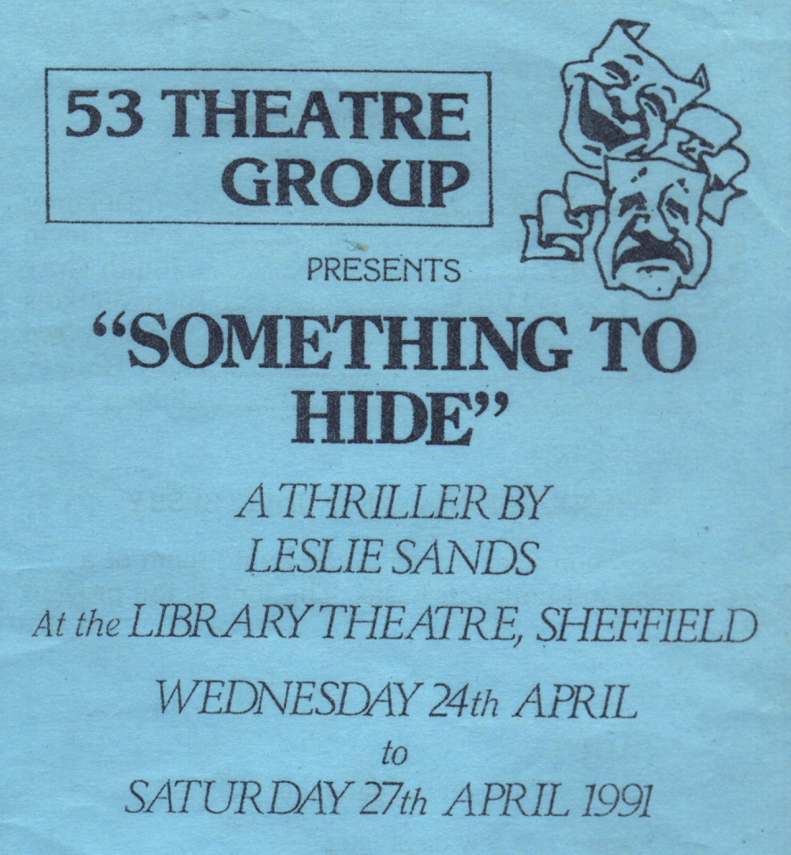
Produced by Maureen Battersby
April 1991
Cast
Howard Holt | Martin Delaney
Julie | Lynn Nevin
Karen Holt | Judith Gray
Inspector Davies | Alan Watkins
Mr Purdie | Brian Ward
Stella | Tracy Hooper
Miss Cunningham | Eileen Nield


