Waltz of the Toreadors, by Jean Anouilh
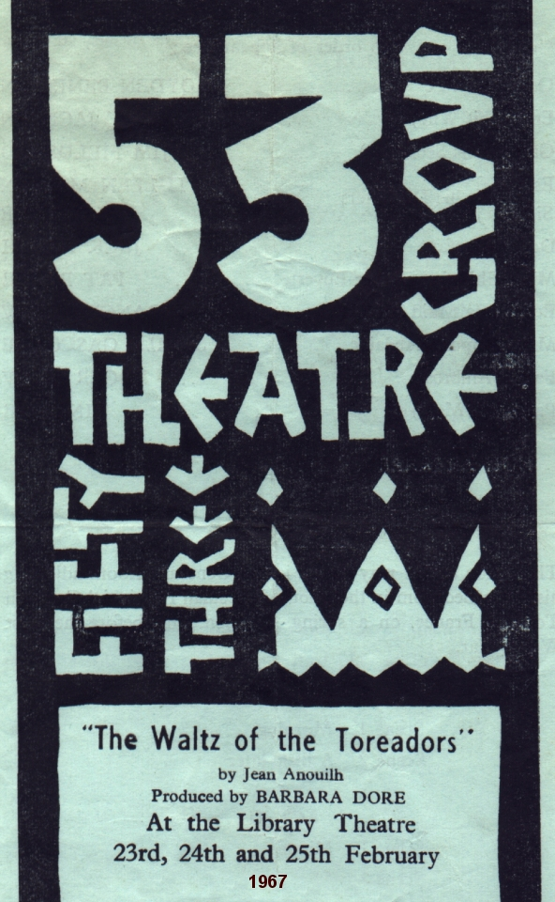
Produced by Barbara Dore
February 1967
Cast
General St Pé | Royden Beniston
Emily | Mary Jackson
Gaston | Jim Fieldsend
Estella | Kathleen Martin
Sidonia | Celia Lane
Dr Bonfant | Jack Booth
Mademoiselle Ghislaine De Ste-Euverte | Pat Payne
Eugenie | Frances Clow
Madame Dupont-Fredaine | Sheila Gascoyne
Father Ambrose | Roger Clow
Pamela | Tina Lee


