The Anniversary, by Bill Macilwraith
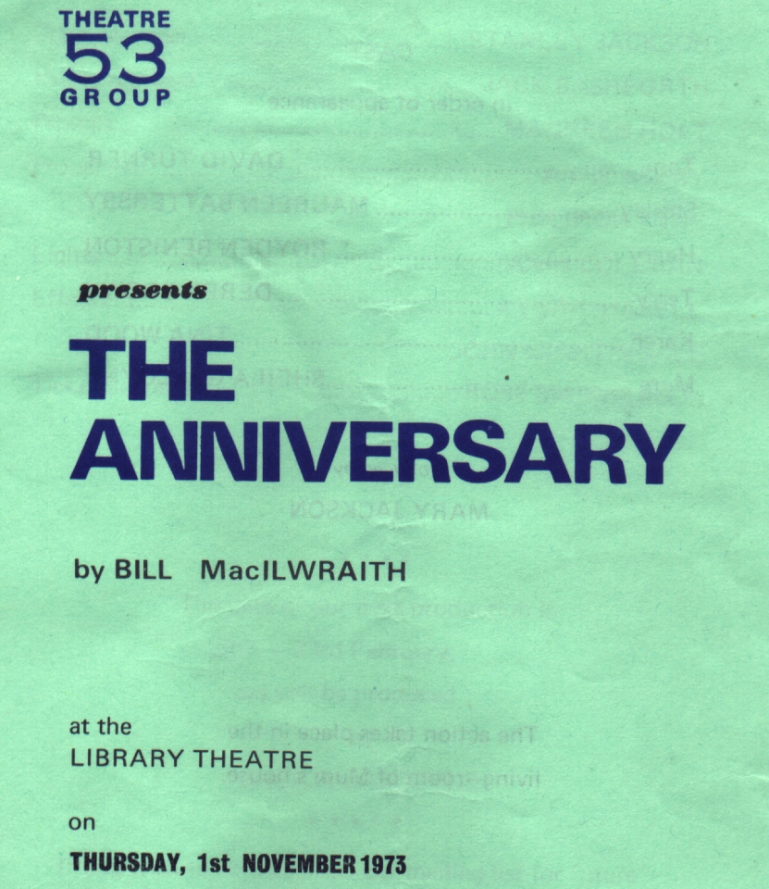
Produced by Mary Jackson
November 1973
Cast
Tom | David Turner
Shirley | Maureen Battersby
Henry | Royden Beniston
Terry | Derek Brown
Karen | Tina Wood
Mum | Sheila Gascoyne


