Key For Two, a comedy by John Chapman & Dave Freeman
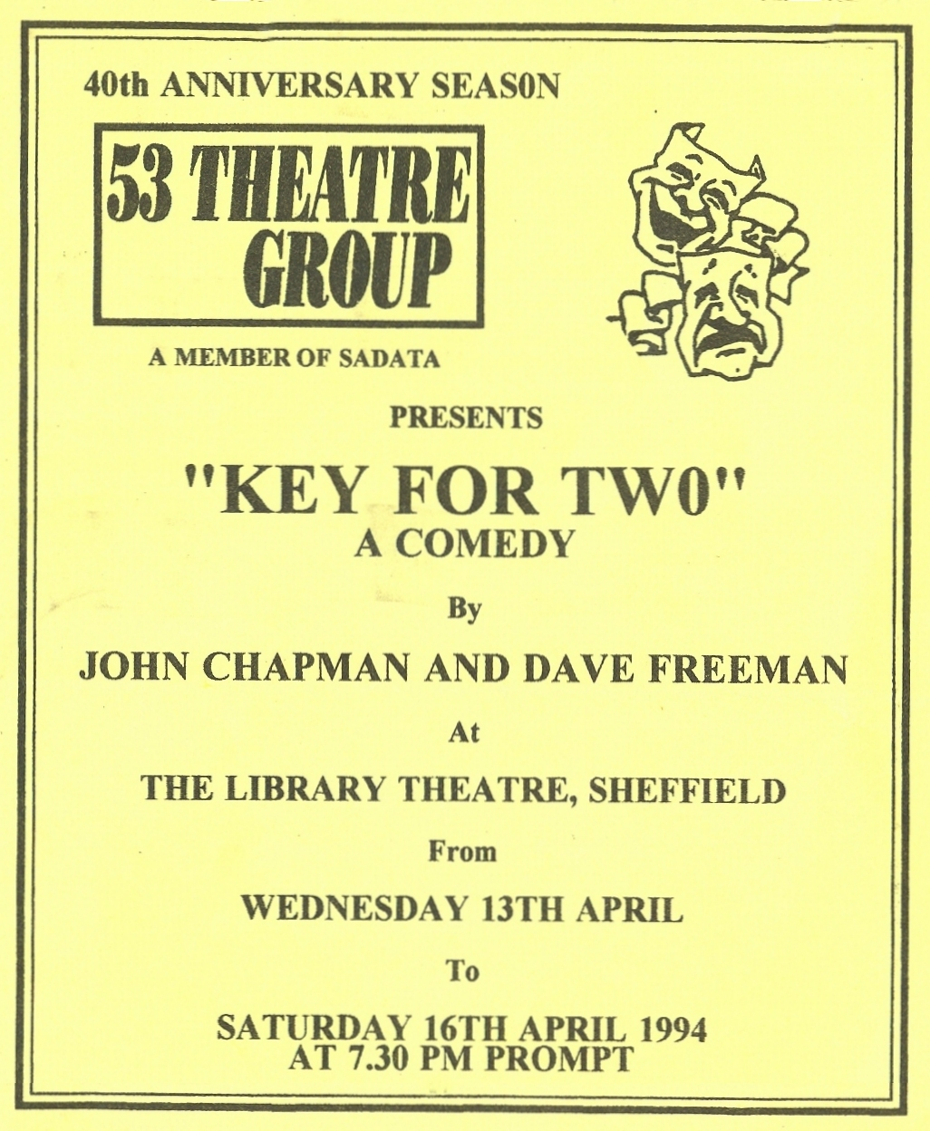
Produced by Sheila Gascoyne
April 1994
Cast
Gordon | John Hughes
Harriet | Maureen Battersby
Alec | George Keyte
Anne | Katharine Briggs
Richard | Harry Crawley
Magda | Sheila Gascoyne
Mildred | Judith Gray


