Night Must Fall, a drama/thriller by Emlyn Williams
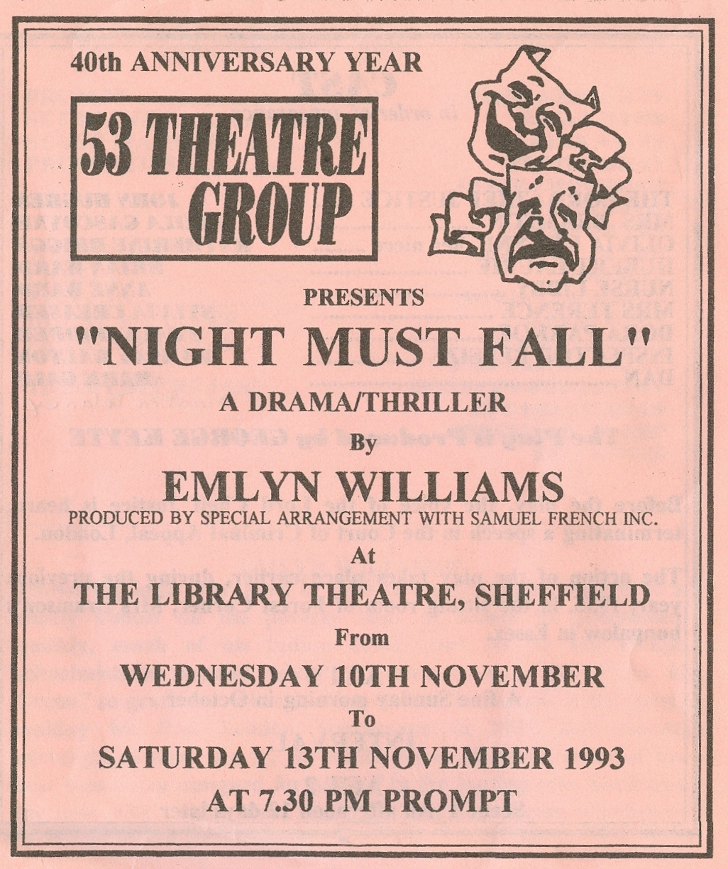
Produced by George Keyte
November 1993
Cast
The Lord Chief Justice | John Hughes
Mrs Bramson | Sheila Gascoyne
Olivia Grayne | Katharine Briggs
Hubert Laurie | Brian Ward
Nurse Libby | Anne Ward
Mrs Terence | Sylvia Creaser
Dora Parkoe | Tracy Hooper
Inspector Belsize | Ramsay Walton
Dan | Martin Delaney


