A Murder Has Been Arranged, by Emlyn Williams
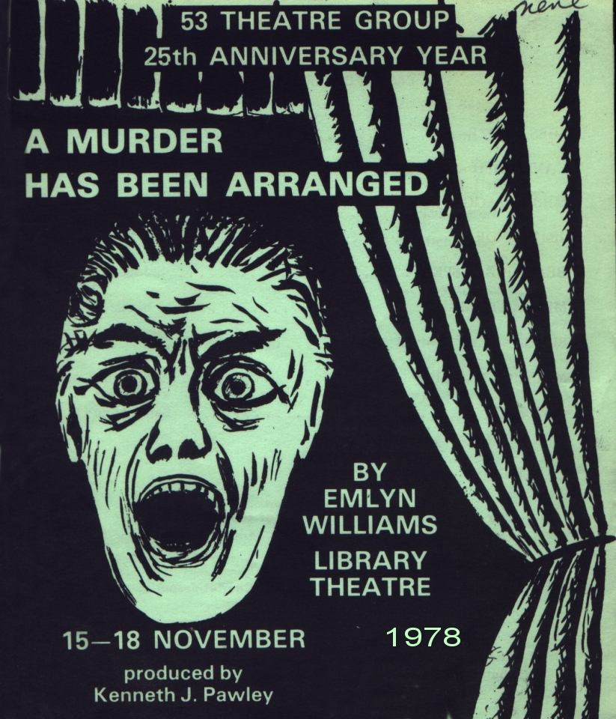
Produced by Kenneth J Pawley
November 1978
Cast
Miss Groze | Pat Mills
Cavendish | Tony Reynolds
Mrs Wragg | Jean Challoner
Jimmy North | Wayne Biggin
Beatrice Jasper | Joyce Crowther
Mrs Arthur | Sheila Gascoyne
Sir Charles Jasper | Jim Russell
Maurice Mullins | Howard Wright
A Woman | Sally Anne Oscroft

