Off the Hook, a farce by Derek Benfield
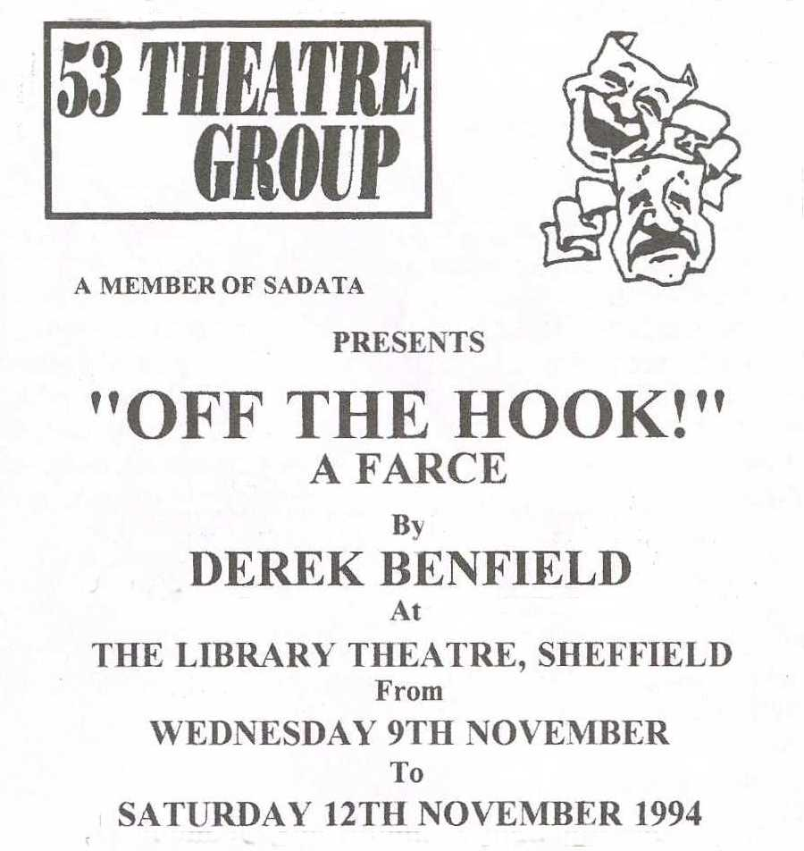
Produced by Sylvia Creaser
November 1994
Cast
Norah Catchpole | Anne Ward
Edna | Judith Gray
Fred Baxter | George Keyte
Major Catchpole | Harry Crawley
Charlie Mullins | John Cross
Harold Spook | Kevin Daly
Mrs Fletcher-Brewer | Sheila Gascoyne
Carol | Katherine Briggs
Polly | Elaine Geraghty
Mr Parkinson | Ramsay Walton


