A Bird in the Hand, by Derek Benfield
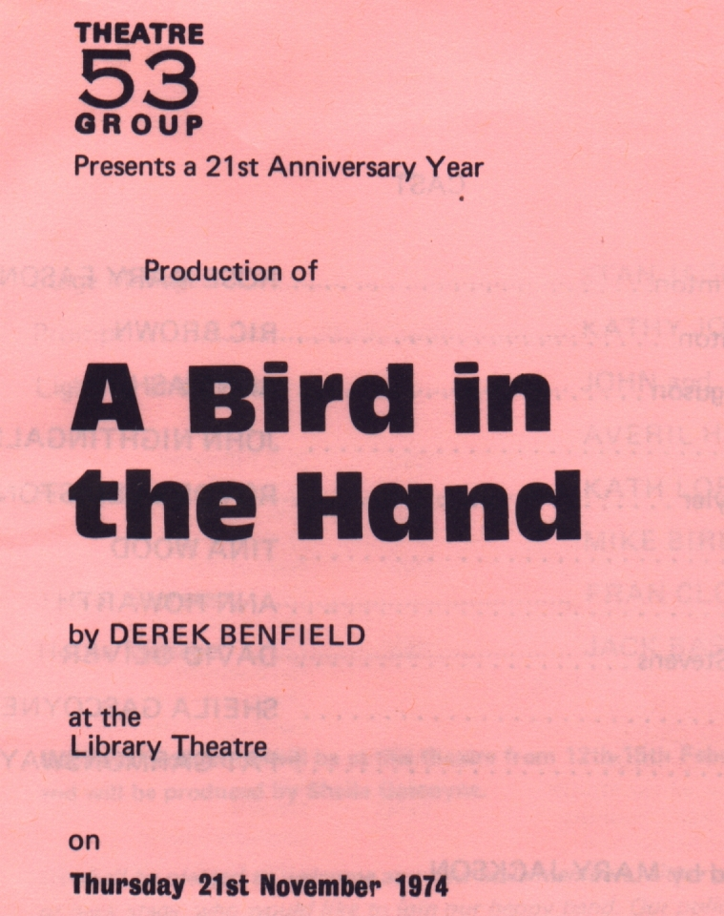
Produced by Mary Jackson
November 1974
Cast
Sylvia Winton | Rose Mary Eason
Max Winton | Ric Brown
Miss Ferguson | Anne Ashby
Perch | John Nightingale
Harry Tyler | Royden Beniston
Peggy | Tina Wood
Sue | Ann Howarth
George Stevens | David Oliver
Helen | Sheila Gascoyne
Frances | Pat Garmondsway


