His, Hers and Theirs, by Hugh & Margaret Williams
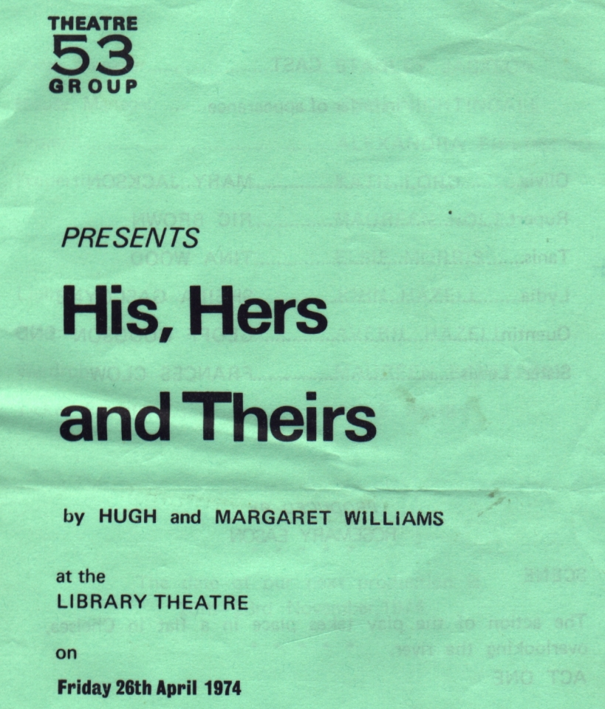
Produced by Rose Mary Eason
April 1974
Cast
Olivia | Mary Jackson
Rupert | Ric Brown
Tanis | Tina Wood
Lydia | Sheila Gascoyne
Quentin | Geoff Hodgson
Sister Lewis | Frances Clow


