Spring and Port Wine, by Bill Naughton
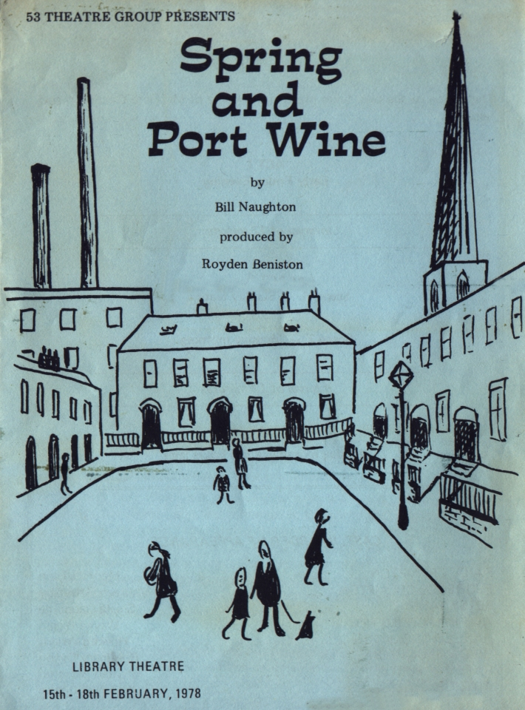
Produced by Royden Beniston
February 1978
Cast
Daisy Crompton | Mary Jackson
Florence Crompton | Maureen Battersby
Betsy Jane | Sheila Gascoyne
Wilfred Crompton | Wayne Biggin
Harold Crompton | Howard Wright
Hilda Crompton | Rosemary Dyson
Rafe Crompton | Royden Beniston
Arthur | John Nightingale


