Ladies in Retirement, a thriller by Edward Percy

& Reginald Denham
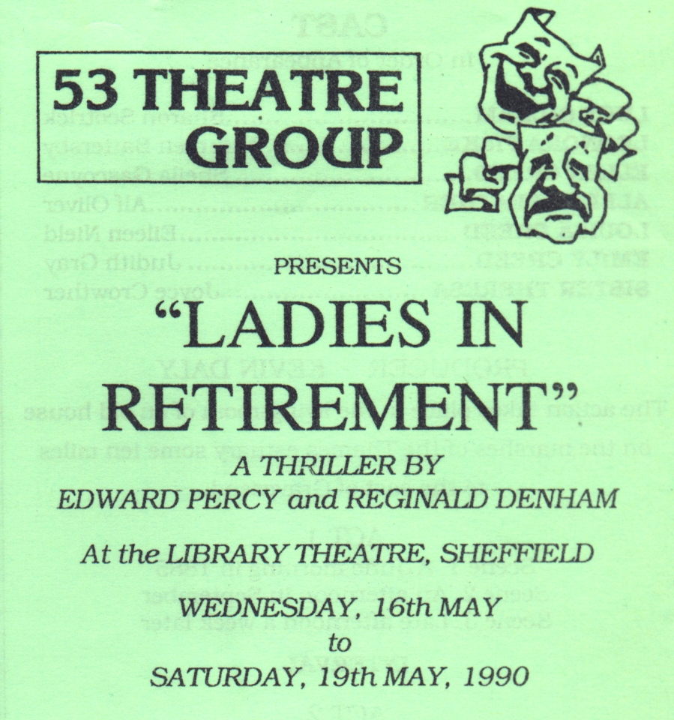
Produced by Kevin Daly
May 1990
Cast
Lucy Gilham | Sharon Scotrick
Leonora Fiske | Maureen Battersby
Ellen Creed | Sheila Gascoyne
Albert Feather | Alf Oliver
Louisa Creed | Eileen Nield
Emily Creed | Judith Gray
Sister Theresa | Joyce Crowther


