Doctor in the House, by Ted Willis
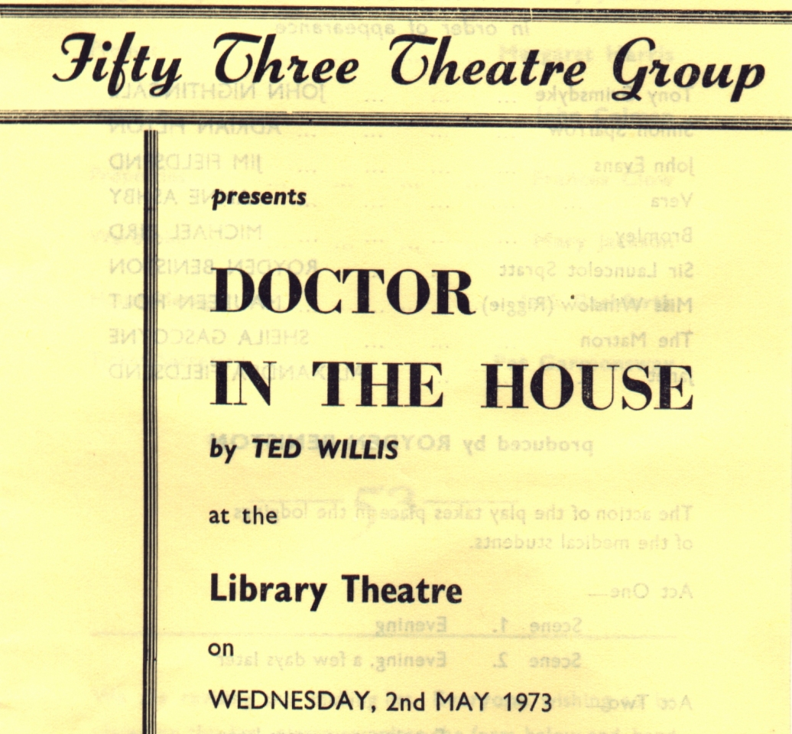
Produced by Royden Beniston
May 1973
Cast
Tony Grimsdyke | John Nightingale
Simon Sparrow | Adrian Pilton
John Evans | Jim Fieldsend
Vera | Anne Ashby
Bromley | Michael Bird
Sir Launcelot Spratt | Royden Beniston
Miss Winslow (Riggie) | Maureen Holt
The Matron | Sheila Gascoyne
Janet | Alexandra Fieldsend

