Barefoot in the Park, by Neil Simon
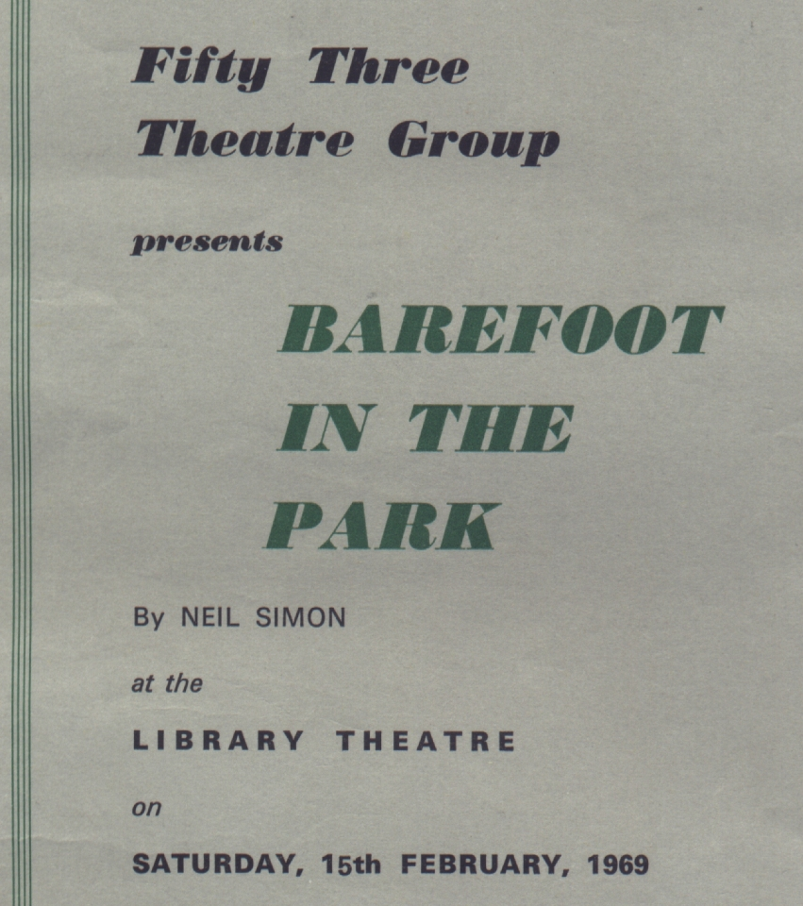
Produced by Mary Jackson
February 1969
Cast
Corrie Bratter | Tina Lee
Telephone Man | Roger Clow
Delivery Man | David Helliwell
Paul Bratter | John Geraghty
Mrs Banks | Pat Garmondsway
Victor Velasco | Royden Beniston


