The Geese Are Getting Fat, by Arthur Watkyn
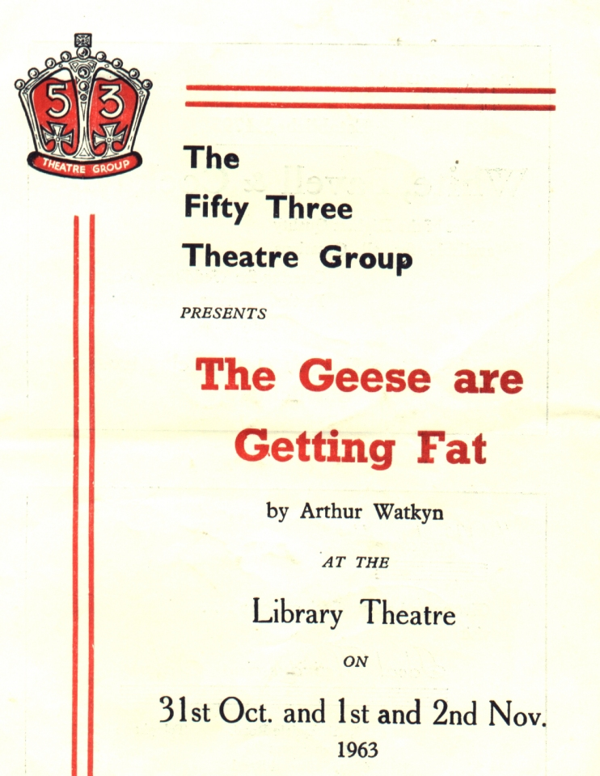
Produced by Dorothy Jackson
November 1963
Cast
Clive Wyndham | Roland Jackson
Joyce Wyndham | Mary Jackson
Pat Wyndham | Janet Thornley
Edward Pratt | Ken Reynolds
Greta Jorgenson | Eve Palmer
Sheila Pratt | Joan Coulson
Victor Wyndham | John Butterworth
Melvyn Pugh | Neville Palmer
Bobby Cartwright | Jim Fieldsend
Delia Moss | Sheila Gascoyne
Dr Nairn | Royden Beniston


