Corinth House, by Pamela Hansford Johnson
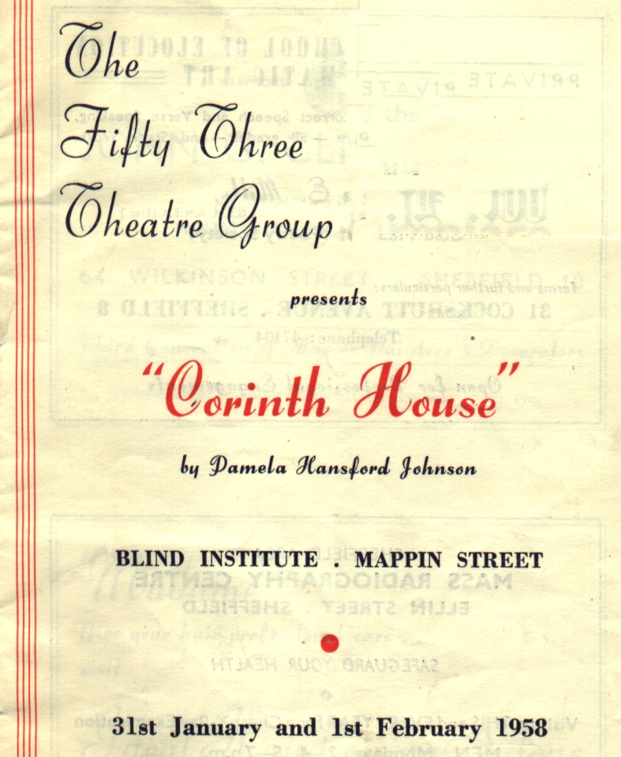
Produced by Royden Beniston
February 1958
Cast
Miss Malleson | Kitty Sellars
Nora | Barbara Dore
Mrs Beauclerc | Alice Ludlam
Miss Figgis | Margaret Perkins
Mrs Heysham | Pat Kibble
Major Shales | Bill Moss
Madge Donnythorpe | Maureen Evans

