Fools Rush In, by Kenneth Horne
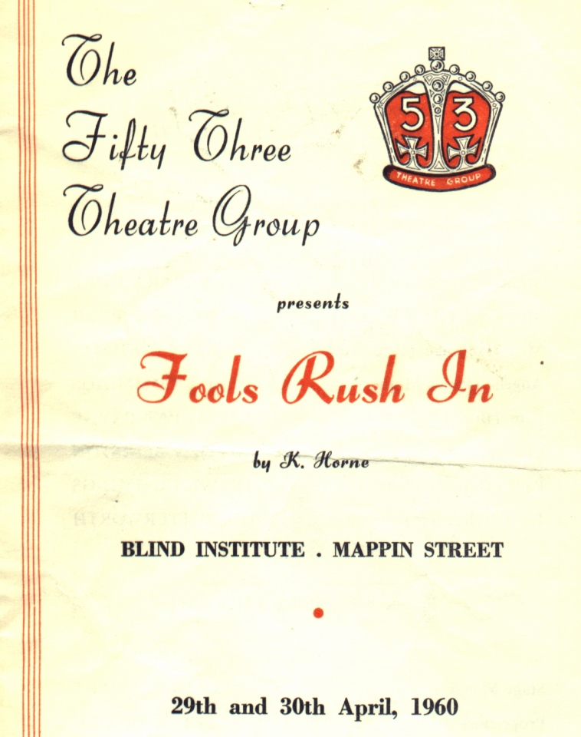
Produced by Aliuce Ludlam
April 1960
Cast
Millicent | Barbara Dore
Mrs Coot | Renee Dilger
Mrs Mandrake | Joan Coulson
Angela | Kathleen Cummings
Pam | Pat Payne
Charles | Royden Beniston
Paul | Derek Cummings
Joe | John Butterworth


