Goodnight Mrs Puffin, by Arthur Lovegrove
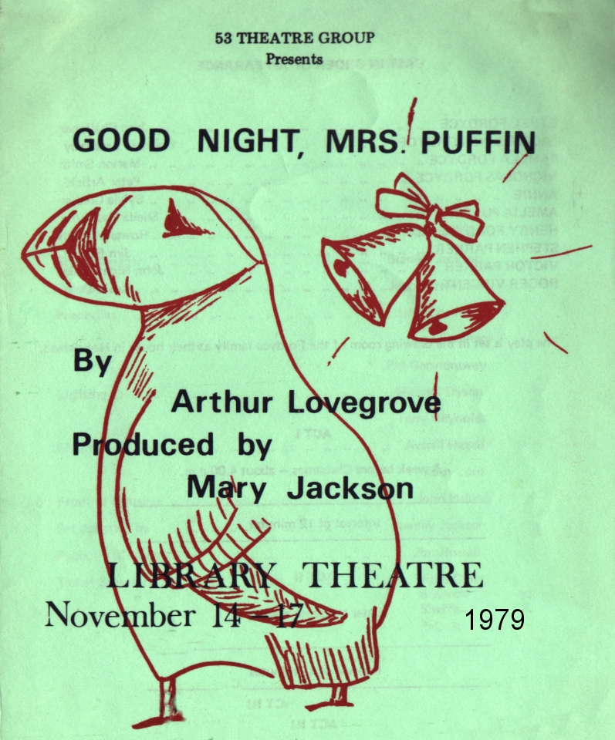
Produced by Mary Jackson
November 1979
Cast
Ethel Fordyce | Jean Challoner
Jacqueline Fordyce | Maureen Battersby
Pamela Fordyce | Marion Smith
Nicholas Fordyce | Peter Arfield
Annie | Sylvia Creaser
Amelia Puffin | Sheila Gascoyne
Henry Fordyce | Howard Wright
Stephen Parker | Jim Russell
Victor Parker | John Nightingale
Roger Vincent | Kevin Daly


