Mad About Men, by Peter Blackmore
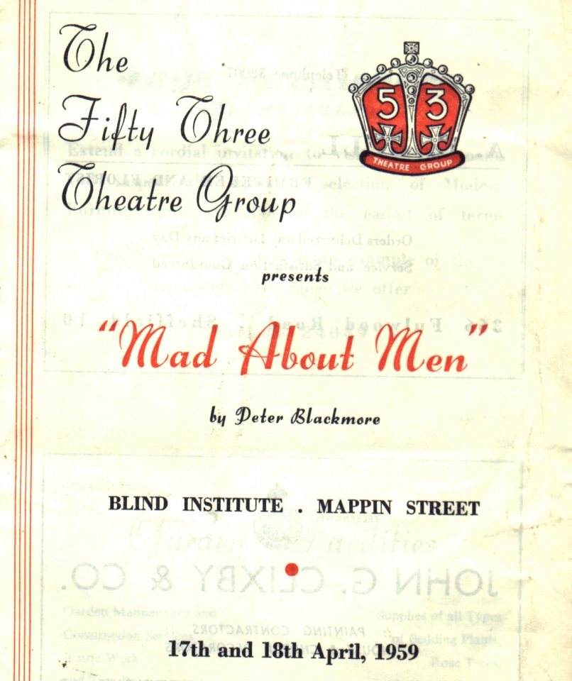
Produced by Alice Ludlam
April 1959
Cast
Mrs Forster | Joan Coulson
Barbara Davenport | Margaret Perkins
Jeff Saunders | Keith Harrop
Caroline Trewella | Barbara Dore
later doubling as Miranda
Nurse Carey | Sheila Slack
Barclay Sutton | Royden Beniston
Ronald Baker | Arthur Bridges
PC Biggs | Chris Unwin
Jane Peters | Pat Jones
Professor Fergus | Peter Dilger


