Living Together, a play by Alan Ayckbourn
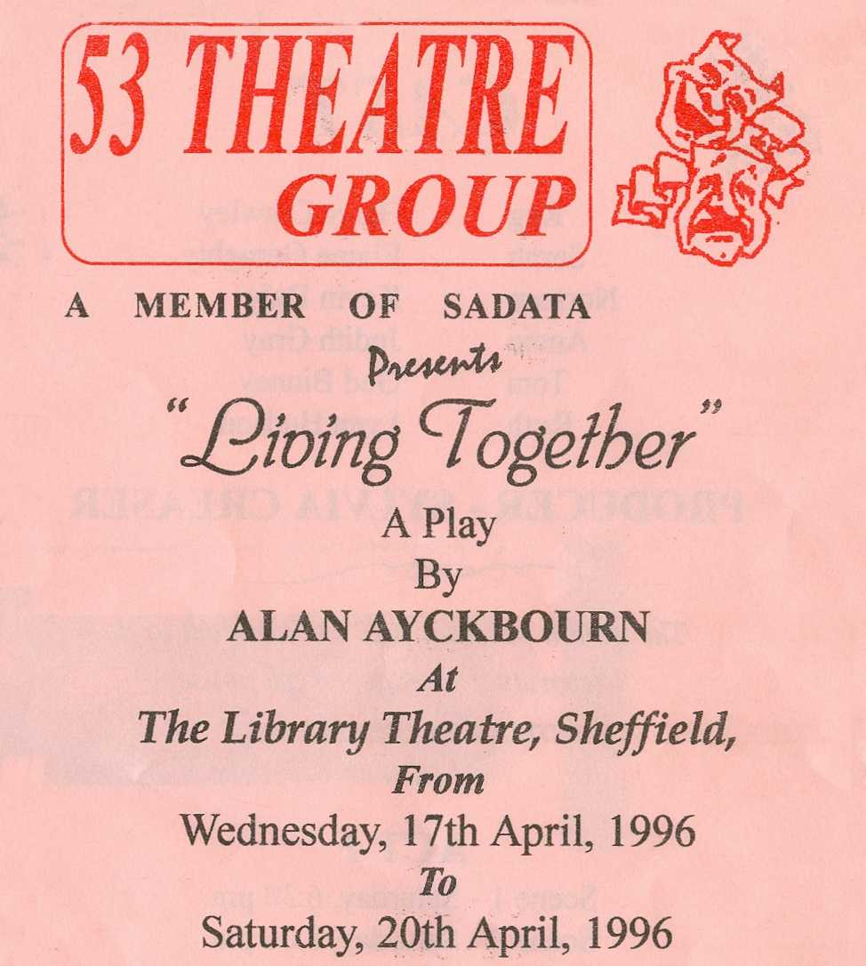
Produced by Sylvia Creaser
April 1996
Cast
Reg | Harry Crawley
Sarah | Elaine Geraghty
Norman | Kevin Daly
Annie | Judith Gray
Tom | Ged Binney
Ruth | Lynn Hudson


