Trial and Error, by Kenneth Horne
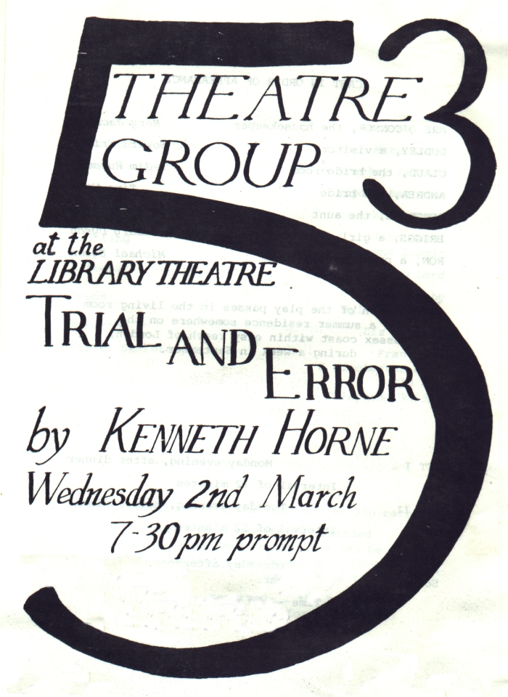
Produced by Ruth Hawkins
March 1977
Cast
Mrs O'Connor | Mary Jackson
Dudley | Howard Wright
Claud | Jim Russell
Andrea | Tina Wood
Gertrude | Sheila Gascoyne
Briggs | Rosemary Dyson
Ron | Michael Dyson


