Hobson's Choice, a comedy by Harold Brighouse
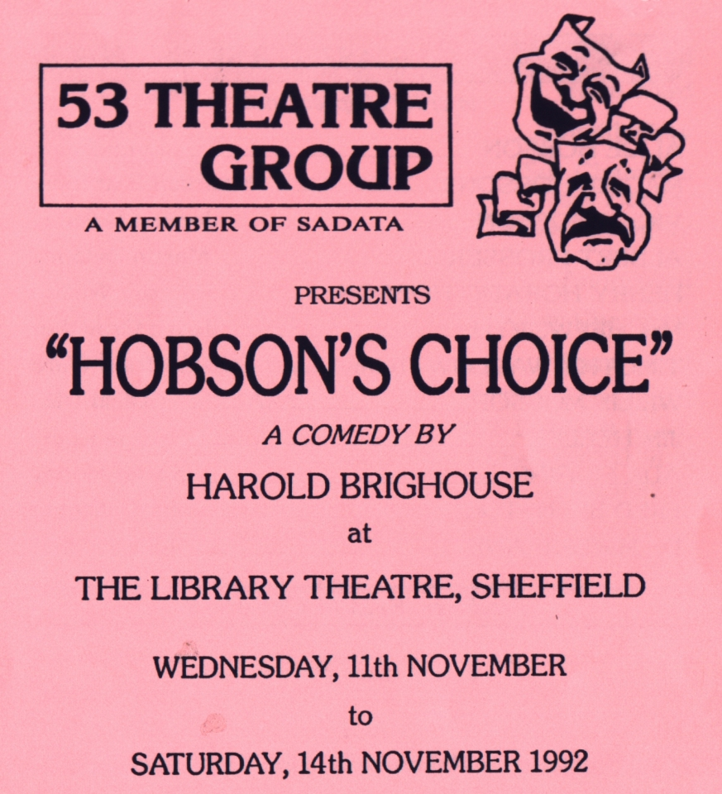
Produced by Sylvia Creaser
November 1992
Cast
Alice Hobson | Lynn Nevin
Maggie Hobson | Maureen Battersby
Vicky Hobson | Joanne Delaney
Albert Prosser | Martin Delaney
Henry Horatio Hobson | Ramsay Walton
Mrs Hepworth | Joyce Crowther
Timothy Wadlow (Tubby) | Brian Ward
Willie Mossop | Kevin Daly
Jim Heeler | George Keyte
Ada Figgins | Karen Moody
Fred Beenstock | John Gallagher
Dr MacFarlane | John Hughes


