Separate Tables, by Terence Rattigan
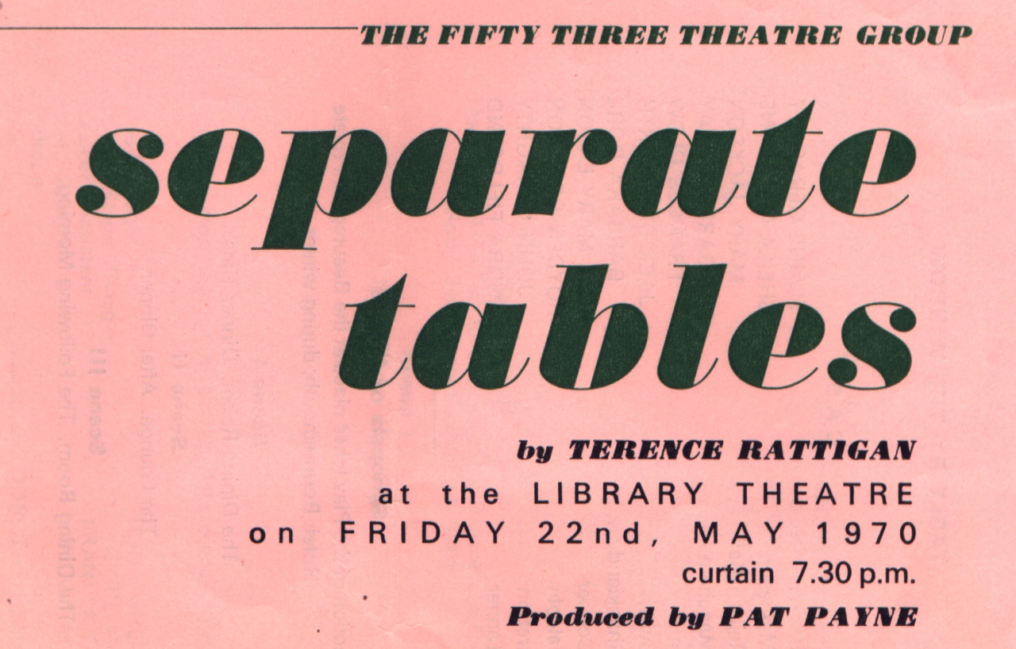
Produced by Pat Payne
May 1970
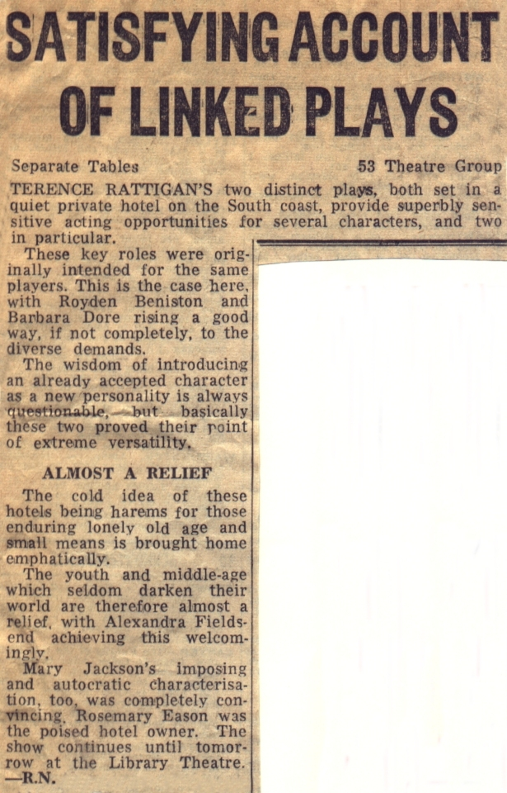
Cast | TABLE BY THE WINDOW
Mabel | Elaine Geraghty
Lady Matheson | Sheila Gascoyne
Mrs Railton-Bell | Mary Jackson
Miss Meacham | Pat Garmondsway
Doreen | Frances Clow
Mr Fowler | Jack Bashforth
Mrs Shankland | Barbara Dore
Miss Cooper | Rose Mary Eason
Mr Malcolm | Royden Beniston
Mr Stratton | John Geraghty
Miss Tanner | Alexandra Fieldsend
Cast | TABLE NUMBER SEVEN
Mrs Stratton | Alexandra Fieldsend
Mr Stratton | John Geraghty
Major Pollock | Royden Beniston
Mr Fowler | Jack Bashforth
Miss Cooper | Rose Mary Eason
Mrs Railton-Bell | Mary Jackson
Miss Railton-Bell | Barbara Dore
Lady Matheson | Sheila Gascoyne
Miss Meacham | Pat Garmondsway
Mabel | Elaine Geraghty
Doreen | Frances Clow

