The Love of Four Colonels, by Peter Ustinov
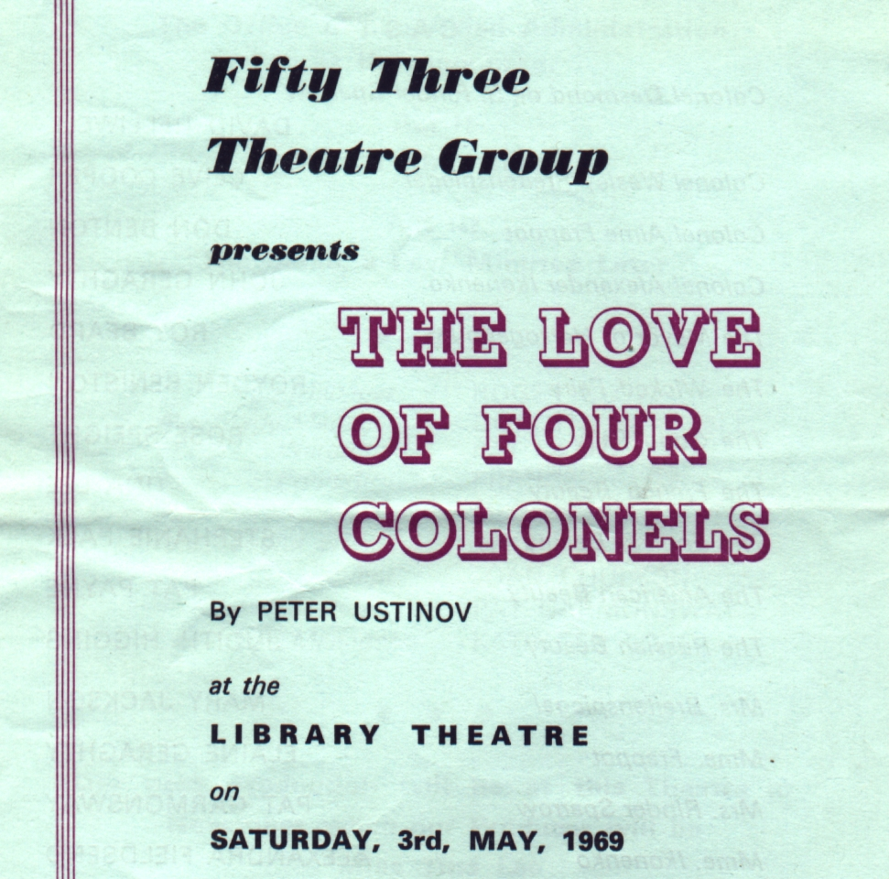
Produced by Barbara Dore
May 1969
Cast
Col Desmond de S Rinder Sparrow | David Helliwell
Col Wesley Breitenspiegal | Clive Cooper
Col Aime Frappot | Don Benton
Col Alexander Ikonenko | John Geraghty
The Mayor of Herzogenburg | Roy Beard
The Wicked Fairy | Royden Beniston
The Good Fairy | Rose Speight
The French Beauty | Tina Lee
The English Beauty | Stephanie Palk
The American Beauty | Pat Payne
The Russian Beauty | Judith Higgins
Mrs Breitenspiegal | Mary Jackson
Madame Frappot | Elaine Geraghty
Mrs Rinder Sparrow | Pat Garmondsway
Madame Ikonenko | Alexandra Fieldsend
The Sleeping Beauty | Bess Whidborne


