Harvey, by Mary Chase
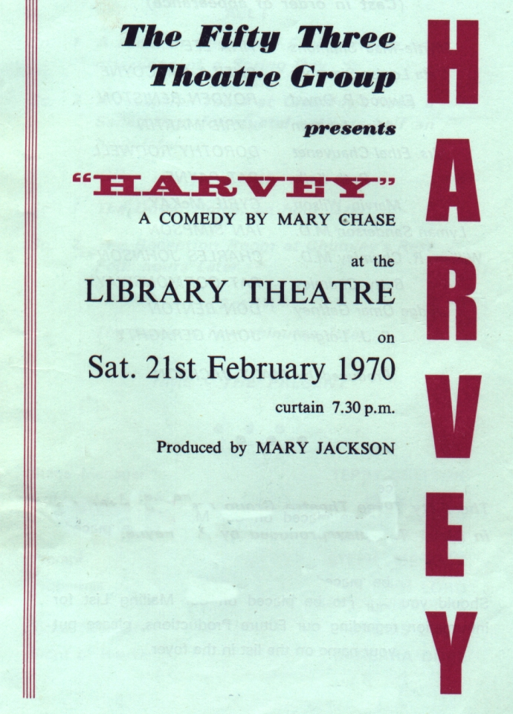
Produced by Mary Jackson
February 1970
Cast
Myrtle-Mae Simmons | Tina Lee
Veta Louise Simmons | Sheila Gascoyne
Elwood P Dowd | Royden Beniston
Miss Johnson | Avril Martin
Mrs Ethel Chauvenet | Dorothy Rodwell
Ruth Kelly | Pat Payne
Marvin Wilson | Cyril McKay
Lyman Sanderson MD | Ian Simpson
William R Chumley MD | Charles Johnson
Betty Chumley | Pat Garmonsway
Judge Omar Gaffney | Don Benton
E J Lofgren | John Geraghty


