The Killing of Sister George, by Frank Marcus
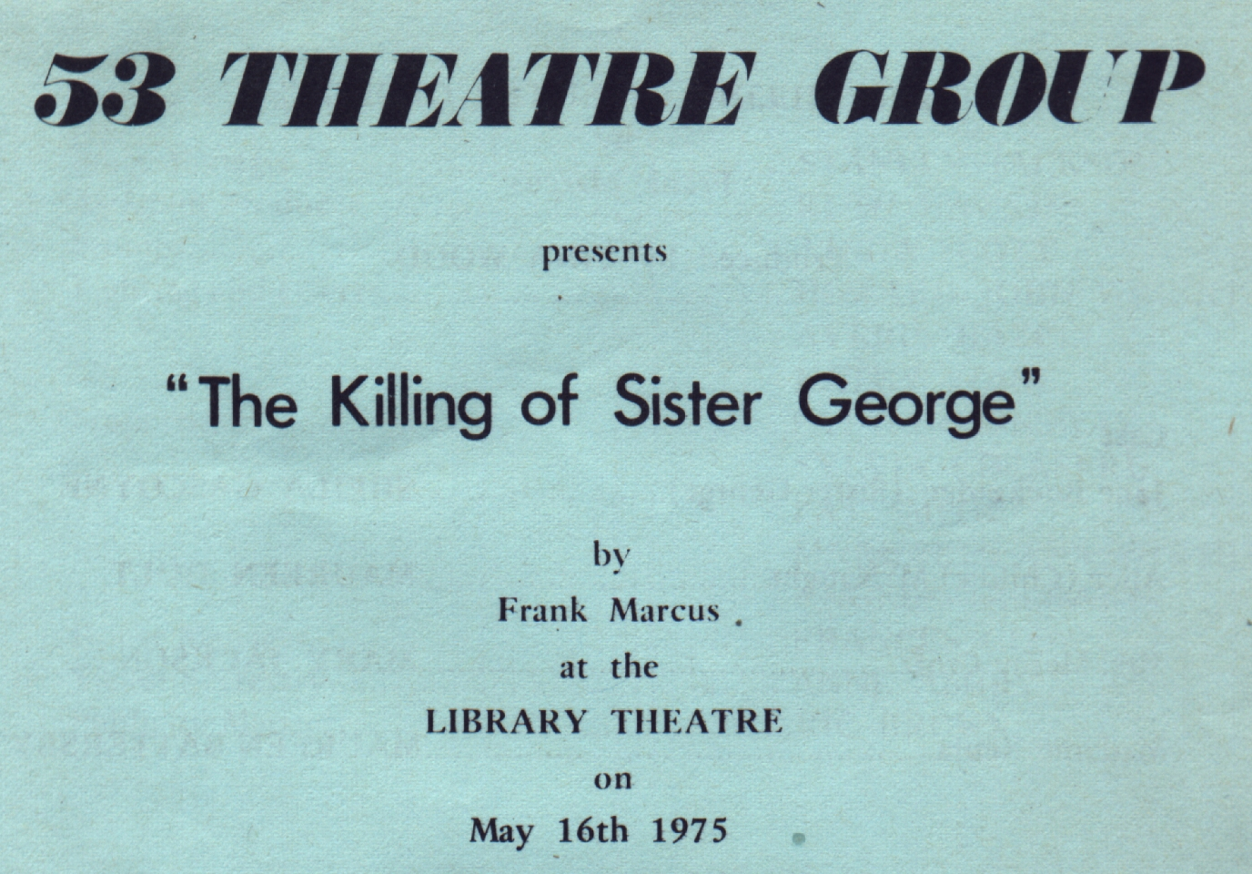
Produced by Tina Wood
May 1975
Cast
June Buckridge (Sister George) | Sheila Gascoyne
Alice (Childie) McNaught | Maureen Holt
Mrs Mercy Croft | Mary Jackson
Madame Xenia | Maureen Battersby


